**Open Ended Experiment**

**Advance Java Programming**

**IT-404**

**Survey Tool for Smartphone Recommendation**



**Amity School of Engineering and Technology**

**Amity University Uttar Pradesh**

**Submitted To: Submitted By:**

**Dr. Shilpi Sharma Rahul Sharma- A2305218435**

**ASET Akshay Kumar – A2305218445**

**Mohit Yadav-A2305218459**

**Kuldeep Dwivedi- A2305218477**

**Open-Ended Project**

**Survey Tool for Smartphone Recommendation**

**Topic and Contribution by Each Member of the Group**

|  |  |  |  |
| --- | --- | --- | --- |
| Name | Enrollment No. | Section | Topic/Contribution |
| Akshay Kumar Raghav | A2305218445 | 6CSE7Y | Trained the model by feeding in input data of smartphones |
| Kuldeep Dwivedi | A2305218477 | 6CSE7Y | Database |
| Mohit Yadav | A2305218459 | 6CSE7Y | Designing Algo for Recommendation |
| Rahul Sharma | A2305218435 | 6CSE7X | Writing code for JSP Pages |

**Open-Ended Project**

**Survey Tool for Smartphone Recommendation**

**Objective:**

The idea was to develop a survey tool which can be used to collect results from various users about smartphones and we added a ability to the web app to recommend a smartphone using the inputs.

**Theory:**

**Java Server Pages** is a server-side web technology which is used to create web applications. JSP pages are the text documents which contain two types of text namely static content and dynamic content. Static content can be expressed in any text-based format like HTML whereas the dynamic content comprises of the Java code. JSP technology here combines the static content with the Java code, hence making it a dynamic web page.

**Features of JSP technology:**

* JSP allows tag-based programming. Hence, there is no need for expertise in the Java language. HTML tags are easy to use and makes the code readable.
* The building of dynamic web pages that are able to interact with the users in a real-time environment.
* It allows user an easy connection to the database as it mainly connects with the server.

The file extension for the source file of a JSP page is .jsp.

**PreparedStatement:** Use this when you plan to use the SQL statements many times. The PreparedStatement interface accepts input parameters at runtime. The PreparedStatement interface extends the Statement interface, which gives you added functionality with a couple of advantages over a generic Statement object. This statement gives you the flexibility of supplying arguments dynamically.

**Program:**

**Success.jsp:**

<%--

Document : success

Created on : 21 Mar, 2021, 9:52:43 AM

Author : hp

--%>

<%@page contentType="text/html" pageEncoding="UTF-8"%>

<!DOCTYPE html>

<html>

<head>

<meta http-equiv="Content-Type" content="text/html; charset=UTF-8">

<title>Survey</title>

</head>

<style>

body {

background-image: url(smart.jpg);

}

h1{text-align: center;}

</style>

<body>

<form action="question.jsp" method="post">

<h1>Survey Tool</h1>

<h3>Your Name:</h3>

<input type ="text" name ="name"><br>

<h3>Your Date Of Birth:</h3>

<input type="date" name ="dob"><br>

<br>

<input type="submit" value="Submit">

</form>

</body>

</html>

**Questions.jsp:**

<%--

Document : question

Created on : 24 Mar, 2021, 9:58:18 PM

Author : hp

--%>

<%@page contentType="text/html" pageEncoding="UTF-8"%>

<!DOCTYPE html>

<html>

<head>

<meta http-equiv="Content-Type" content="text/html; charset=UTF-8">

<title>Survey</title>

</head>

<style>

body {

background-image: url(smart.jpg);

}

h1{text-align: center;}

h3{text-align: center;}

</style>

<body>

<%

String name = request.getParameter("name");

%>

<form action ="compute.jsp" method="post">

<h1>Survey Tool</h1>

<h3>We will recommend an ideal phone for you on the basis of your answers!!</h3>

<h3>Welcome, <%=name%></h3>

<h4>

1.) Which OS would you prefer?

</h4>

<input type = "radio" name = "OS" value="iOS"/>

iOS<br>

<input type = "radio" name = "OS" value="Android"/>

Android<br>

<input type = "radio" name = "OS" value="Other"/>

Other<br>

<h4>

2.) What is your average smartphone usage time for a day?

</h4>

<input type = "radio" name = "usage" value="<3hr"/>

Less than 3 hours<br>

<input type = "radio" name = "usage" value="3-5Hr"/>

3 to 5 hours<br>

<input type = "radio" name = "usage" value=">5Hr"/>

More than 5 hours<br>

<h4>

3.) Do you play heavy games?

</h4>

<input type = "radio" name = "game" value="Yes"/>

Yes<br>

<input type = "radio" name = "game" value="No"/>

No<br>

<input type = "radio" name = "game" value="!often"/>

Not Often<br>

<h4>

4.) What is the first thing you will look in a phone first?

</h4>

<input type = "radio" name = "first" value="cam"/>

Camera<br>

<input type = "radio" name = "first" value="per"/>

Performance<br>

<input type = "radio" name = "first" value="disp"/>

Display Quality<br>

<input type = "radio" name = "first" value="battery"/>

Battery<br>

<h4>

5.) What kind of security lock you will prefer?

</h4>

<input type = "radio" name = "lock" value="face"/>

Face Unlock Only<br>

<input type = "radio" name = "lock" value="fing"/>

Secure Face Unlock with Fingerprint Sensor<br>

<h4>

6.) What is the ideal position of a fingerprint sensor on your ideal smartphone?

</h4>

<input type = "radio" name = "sensor" value="rear"/>

Rear<br>

<input type = "radio" name = "sensor" value="front"/>

Front(In-Display Sensor)<br>

<input type = "radio" name = "sensor" value="lock"/>

Integrated With Lock Button<br>

<h4>

6.) What is the ideal screen size for you?

</h4>

<input type = "radio" name = "screen" value="size1"/>

Less than 5 inches<br>

<input type = "radio" name = "screen" value="size2"/>

5-6 inches<br>

<input type = "radio" name = "screen" value="size3"/>

More than 6 inches<br>

<h4>

6.) How much should your phone cost?

</h4>

<input type = "radio" name = "cost" value="10k"/>

Less than 10K<br>

<input type = "radio" name = "cost" value="25k"/>

10-25K<br>

<input type = "radio" name = "cost" value="50k"/>

25-50K<br>

<input type = "radio" name = "cost" value="100k"/>

More than 50K<br>

<br>

<input type="submit" value="Submit">

</form>

</body>

</html>

**Compute.jsp:**

<%--

Document : compute

Created on : 25 Mar, 2021, 10:49:25 AM

Author : hp

--%>

<%@ page import = "java.io.*,java.util.*,java.sql.*"%>

<%@page import= "java.util.logging.Level,java.util.logging.Logger" %>

<%@page contentType="text/html" pageEncoding="UTF-8"%>

<!DOCTYPE html>

<html>

<head>

<meta http-equiv="Content-Type" content="text/html; charset=UTF-8">

<title>We're done!!</title>

</head>

<style>

body {

text-align: center;

}

img.center{

display: block;

margin-left: auto;

margin-right: auto;

width: 33%;

height: 33%;

}

h1{text-align: center}

h2{text-align: center}

a{text-align: center}

</style>

<body>

<h2>Hello Confused User!</h2>

<h3>We are ready to help you!!</h3>

<%

String OS = request.getParameter("OS");

String size = request.getParameter("screen");

String cost = request.getParameter("cost");

String usage = request.getParameter("usage");

String game = request.getParameter("game");

String feature = request.getParameter("first");

String lock = request.getParameter("lock");

String sensor = request.getParameter("sensor");

if(OS.equals("iOS")){

if(!size.equals("size1")){%>

<h2>You can go for iPhone 12!</h2>

<img src="iphone12.jpg" alt="iPhone12" class="center"><br>

Link to Amazon: <a href="https://www.amazon.in/New-Apple-iPhone-12-64GB/dp/B08L5TGWD1" target="_blank">Buy on Amazon!</a><br>

Link to Flipkart: <a href="https://www.flipkart.com/apple-iphone-12-white-64-gb/p/itm8b88bdc03cd79" target="_blank">Buy on Flipkart!</a>

<%

}else if(size.equals("size1"))

{

%>

<h2>iPhone SE(2020) can be a good option for you!</h2>

<img src="iphonese.jpg" alt="iPhonese" class="center"><br>

Link to Apple.com: <a href="https://www.apple.com/in/shop/buy-iphone/iphone-se" target="_blank">Buy on Apple.com!</a><br>

Link to Flipkart: <a href="https://www.flipkart.com/apple-iphone-se-black-64-gb/p/itm832dd5963a08d" target="_blank">Buy on Flipkart!</a>

<%

}

} else if(OS.equals("Android")){

if(cost.equals("10k")){

%>

<h2>You can go for Redmi 9 Prime!</h2>

<img src="redmi9.jpg" alt="redmi9" class="center"><br>

Link to Amazon: <a href="https://www.amazon.in/Redmi-Prime-Storage-Display-Camera/dp/B08697MJDK/ref=sr_1_3?dchild=1&keywords=redmi+9+prime&qid=1616945387&sr=8-3" target="_blank">Buy on Amazon!</a><br>

Link to Flipkart: <a href="https://www.flipkart.com/redmi-9-prime-space-blue-64-gb/p/itmddf6787a707d2?pid=MOBFUT9M84NDDYQN&lid=LSTMOBFUT9M84NDDYQN9NHPW2&marketplace=FLIPKART&q=smartphones&store=tyy%2F4io&srno=s_1_4&otracker=search&otracker1=search&fm=SEARCH&iid=c23c99b5-8e22-4f02-ba41-1ce0f66170cc.MOBFUT9M84NDDYQN.SEARCH&ppt=sp&ppn=sp&ssid=159dvoumt6qpthq81616945188270&qH=6ea4465d0add4685" target="_blank">Buy on Flipkart!</a>

<%

}

else if(cost.equals("25k")){

%>

<h2>You can go for iQOO 3 5G!</h2>

<img src="iqoo3.jpg" alt="iqoo3" class="center"><br>

Link to Amazon: Not Available on Amazon!<br>

Link to Flipkart: <a href="https://www.flipkart.com/iqoo-3-tornado-black-128-gb/p/itm7d075bc17be11?pid=MOBFP4P2CESTHKKR&lid=LSTMOBFP4P2CESTHKKRMXBL0O&marketplace=FLIPKART&q=smartphones&store=tyy%2F4io&srno=s_1_10&otracker=search&otracker1=search&fm=SEARCH&iid=1a6dd853-b16f-4717-a465-c82ec13bdfdb.MOBFP4P2CESTHKKR.SEARCH&ppt=sp&ppn=sp&ssid=r88z58bmg13qneo01616946072879&qH=6ea4465d0add4685" target="_blank">Buy on Flipkart!</a>

<%

}

else if(cost.equals("50k")){

%>

<h2>One Plus 8T would be a nice option for you!</h2>

<img src="op8.jpg" alt="op8" class="center"><br>

Link to Amazon: <a href="https://www.amazon.in/OnePlus-Mirror-Black-128GB-Storage/dp/B085J17VVP/ref=sr_1_5?dchild=1&keywords=oneplus&qid=1616946765&sr=8-5" target="_blank">Buy on Amazon!</a><br>

Link to Flipkart: Not Available on Flipkart!<br>

<%

}

else if(cost.equals("100k")){

%>

<h2>You can go for Samsung S21 Ultra!</h2>

<img src="s21.jpg" alt="s21" class="center"><br>

Link to Amazon: <a href="https://www.amazon.in/Samsung-Galaxy-Phantom-Storage-Active/dp/B08LRDTN6H/ref=sr_1_3?dchild=1&keywords=s21+ultra&qid=1616947060&sr=8-3" target="_blank">Buy on Amazon!</a><br>

Link to Flipkart: <a href="https://www.flipkart.com/samsung-galaxy-s21-ultra-phantom-silver-256-gb/p/itm33747d3aa16d9?pid=MOBFZ3TMAHBPXYNZ&lid=LSTMOBFZ3TMAHBPXYNZS9EVOI&marketplace=FLIPKART&q=smartphones&store=tyy%2F4io&srno=s_1_10&otracker=search&otracker1=search&fm=SEARCH&iid=66f07abe-9016-41a4-8dd6-677f7f5a95f8.MOBFZ3TMAHBPXYNZ.SEARCH&ppt=sp&ppn=sp&qH=6ea4465d0add4685" target="_blank">Buy on Flipkart!</a>

<%

}

}

%>

<%

try {

Class.forName("org.apache.derby.jdbc.ClientDriver");

Connection conn = DriverManager.getConnection("jdbc:derby://localhost:1527/Surveydb");

Statement stmt = conn.createStatement();

PreparedStatement pstmt = conn.prepareStatement("INSERT INTO Survey VALUES (?,?,?,?,?,?,?,?)");

ResultSet rs;

pstmt.setString(1,OS);

pstmt.setString(2,usage);

pstmt.setString(3,game);

pstmt.setString(4,lock);

pstmt.setString(5,sensor);

pstmt.setString(6,size);

pstmt.setString(7,cost);

pstmt.setString(8,feature);

int i = pstmt.executeUpdate();

conn.close();

} catch (ClassNotFoundException ex) {

}

%>

</body>

</html>

**Output:**

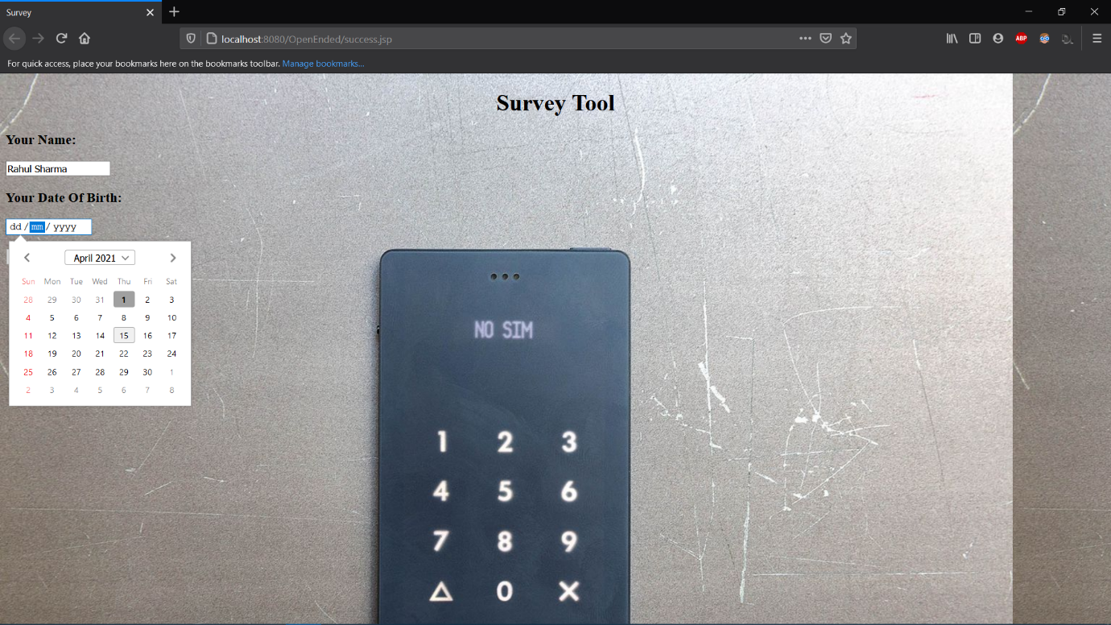

**Figure 1 Home Page**

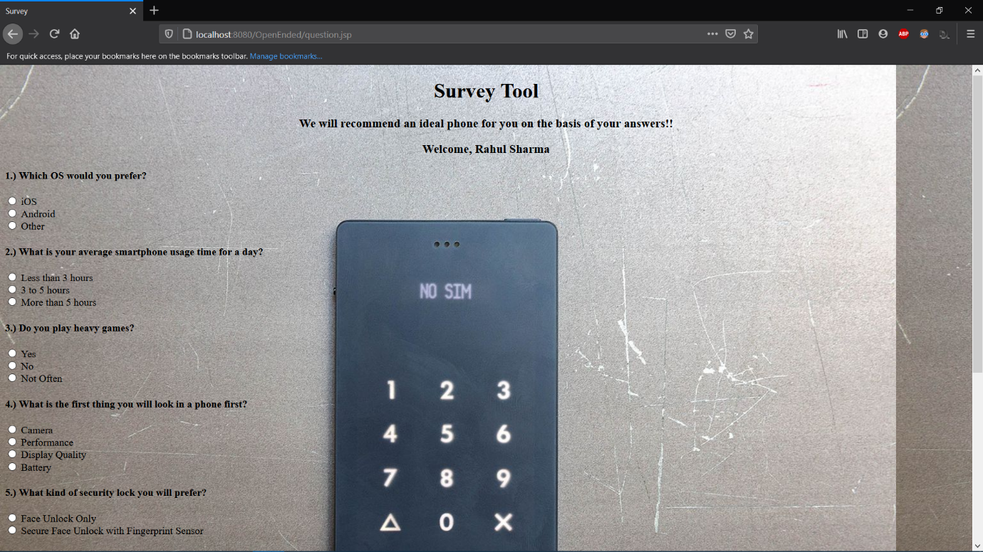

**Figure 2 Questions for the survey.**

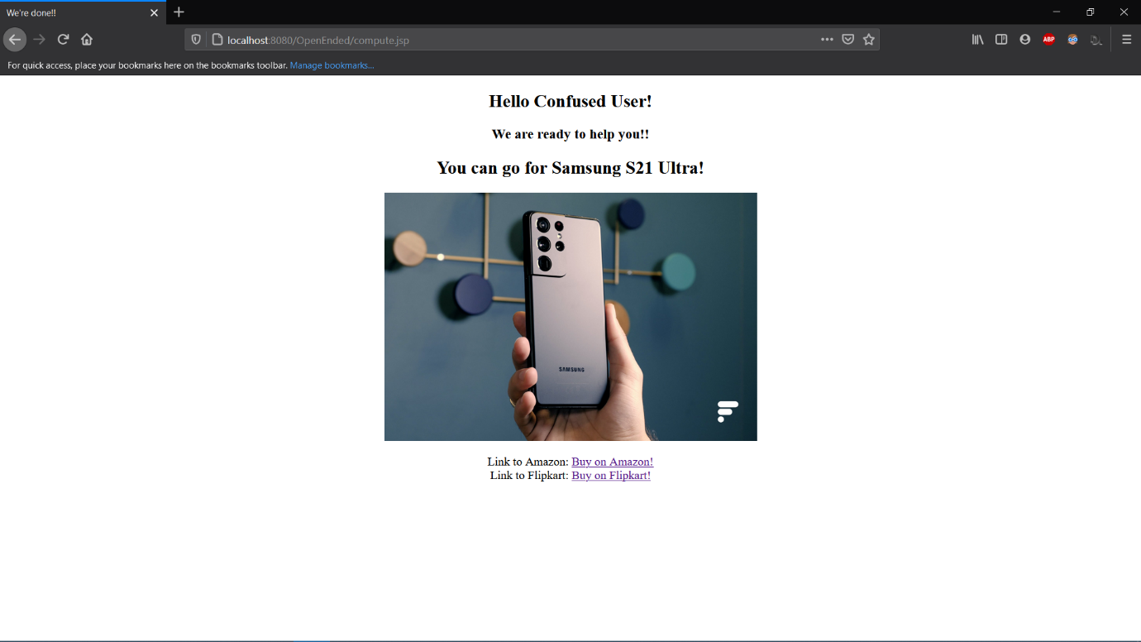

**Figure 3 Phone recommendation on the basis of inputs given by user.**

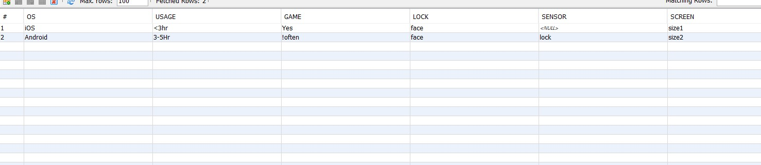

**Figure 4 Data stored in database.**